**Proposal**

**Ameren Relay Project**

**F12-25-RLAY**



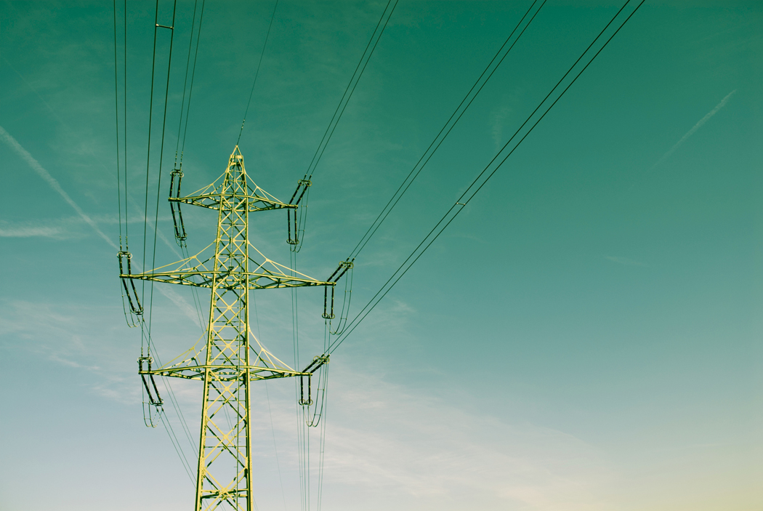

Senior Design (ECE 495p) Fall 2012

**Proposal**

Ameren Relay Project (F12-25-RLAY)

11/6/2012

Project Manager: Hannah Schweiss

Faculty Technical Advisor: Professor C.J. Hatziadoniu

Members:

Hannah Schweiss 636-208-3885 schweissenheimer@sbcglobal.net

Derek Drone 618-313-0912 dronederek@gmail.com

James Smith 217-412-1999 jas92533@gmail.com

Nicholas Reed 708-466-9027 396bbc@gmail.com

Dale Wood 618-315-5025 dalewoodiscool@gmail.com

**Saluki Engineering Company**

**Senior Engineering Design Center**

College of Engineering – Mail code 6603 Carbondale, IL

62901-6603

Phone: 618-457-7837,-7031,-7025

**Ameren Missouri**

1901 Chouteau Ave.

St. Louis, Missouri

*Dear Andy Sugg***,**

This proposal is in response to a request for the design of a mimic board to simulate a relay protection scheme, using a SEL relay, to perform automatic power restoration to a customer facility. The project will be designed to show the usefulness of automatic transfer schemes to minimize outages and protect Ameren’s and the customer’s equipment. Saluki Engineering Company’s team 25 is pleased to be considered for the design work.

The Project is the design of a mimic board that will show the medium voltage topology and system status using indicator lamps. The indicator lamps will show breaker open/close status, incoming line voltage indication, and bus voltage indication. It is the intent of the design team to develop a system capable of minimizing cost, whilst establishing a secure and fully functioning system at a fraction of real world power. Ameren will receive one-line, three-line, breaker schematics, and bill of materials for the mimic board as well as actual subtransmission and distribution voltages.

The proposed work will be done between the months of January and May with a design report being sent at the completion.

Sincerely,

Hannah Schweiss, Project Manager

# Executive Summary

This proposal includes a protective relay will be programmed to act under 13 different cases. Each of these cases will be tested and the relay should act according to the programming. A mimic board will be constructed to show the design of the system. The testing will be as if a real world customer were drawing power from the grid, and the relay will be able to implement corrective action for the case scenario that occurs.

# Restriction on Disclosure of Information

The information provided in or for this proposal is the confidential, proprietary property of the Saluki Engineering Company of Carbondale, Illinois, USA. Such information may be used solely by the party to whom this proposal has been submitted by Saluki Engineering Company and solely for the purpose of evaluating this proposal. The submittal of this proposal confers no right in, or license to use, or right to disclose to others for any purpose, the subject matter, or such information and data, nor confers the right to reproduce, or offer such information for sale. All drawings, specifications, and other writings supplied with this proposal are to be returned to Saluki Engineering Company promptly upon request. The use of this information, other than for the purpose of evaluating this proposal, is subject to the terms of an agreement under which services are to be performed pursuant to this proposal.

Contents

Executive Summary (DD) 4

Restriction on Disclosure of Information (JS) 5

Technical Introduction (HS) 9

Literature Review 9

Introduction (DD) 9

Relay Switches (DD) 9

Relay Control Box (JS) 10

Relays Settings (HS) 11

Control Software (DW) 12

SCADA (DW) 12

Simulation Software (DW) 13

Board Design (NR) 14

Metering (JS) 16

Project Description (DD) 16

Block Diagram 18

*Low Voltage Diagram (JS)* 18

*High Voltage Diagram (NR)* 19

Design Basis (DW) 20

Subsystems 20

Load Design (HS) 20

Power Circuit (NR) 20

Metering (JS) 21

Relay Switches (DD) 21

Control Box (DW) 22

Project Organizational Chart (JS) 22

Action Item List (NR) 22

Timeline (JS) 23

Specifications (HS) 24

Budget/Resources Needed (DD) 24

List of analyses/experiments/simulations to be performed (JS) 24

List of deliverables (HS) 26

SCOPE (JS) 26

Appendix: 28

References: 33

List of Tables

Table 1: Relay switch comparison……………………………………………………………………….10

Table 2: Relay comparison table…………………………………………………………………………11

Table 3: Simulation comparison table…………………………………………………………………14

Table 4: List of components for mimic board………………………………………………….….15

Table 5: Specifications……………………………………………………………………………………..…24

Table 6: Test Conditions..……………………………………………………………………………………26

# Technical Introduction:

Power does not go straight from the generation source to the load. There are many steps along the way that do various things in order to bring the client power. These steps include transmission lines, transformers, and relays. This project has 13 different real world case scenarios that will be tested. It is important to be able to handle these scenarios with as little human interaction as possible because these issues can happen at any time. The faster power is restored or if the customer cannot even tell there ever was an error the better, this means less money lost for companies that use the power and happier customers for the power company.

# Literature Review

## Introduction

This literature review will discuss several things. First the relay control box and the relay settings will be introduced. This section discusses the relay being used. Next, the control software, SCADA, and simulation software will be reviewed. This will determine what type of software is needed to program the relay. Then, relay switches and metering will be compared.

## Relay Switches

A relay is an electrically operated switch. There are several different kinds of relay switches and each has its own purpose and use. A simple electromagnetic relay consists of a wire wrapping and a soft iron core. Electric current passing through the coil creates a magnetic field. This activates the armature which then will either complete the circuit or break it depending on how the relay is constructed. A relay switch can be constructed in the open or closed states. A contractor relay is a heavy duty relay. It has a rating from 10 to up to thousands of amperes. These types of relays, due to their nature, can be very loud. A solid state relay is one that has no moving parts. An advantage of this is increased lifespan of the part. A latching relay is one of the most basic ones, sometimes called a keep relay. This has two states that are both stable. When the coil is energized they switch and then keep to whatever state it is in. If the previous state is needed then the coil is reenergized and it goes to the second state. [11]

There are many factors to consider when picking a relay switch. The first thing to consider is how many contacts, or pins, that are wanted in the relay switch and the type of them. Since the design calls for three phase testing using three phase power throughout the circuit will need to have a 3 pole double throw relay switch. These are commonly referred to as 3PDT relay switches. The next thing is the voltage and current that the contacts are going to need to be able to handle. Since using three phase power, there will not be any need for more than a 300 VAC and 100 amp relay switch. If the current had been extremely high, for example 300 amps, then the board would have selected a contactor. Using these two parameters the correct relay switch can successfully be found that needs to be implemented into the mimic board.

Table 1: Relay Switch Comparison

|  |  |  |
| --- | --- | --- |
| Types of Relay | Current Rating (A) | Lifespan |
| Solid State | Up to 1.2k | Very Long |
| Contactor | 10-300 | Average |
| Latching | 100 | Average |
| Electromagnetic | 100 | Average |

## Relay Control Box

When assigned to program and test a relay for a project, the first task to be accomplished is choosing the relay to be used. In order to choose the correct relay there are three major characteristics to be considered. The protection capabilities of the relay are the most important. If the relay cannot protect against an element that could potentially interrupt the lines (or power flow), that relay should not be used. The other characteristics to be taken into consideration are cost and ease of use. Below is a table showing the abilities of the various distribution relays. Many of these relays have the protection capabilities required for this project, but the client, Ameren, has reduced the options to two relays. The two relays under consideration for the project are the SEL 351S and the SEL 451. As shown in the comparison table below, both relays in question have the applications and protection capabilities that are needed.

Table 2: Relay comparison table [2], [3]

|  |  |  |  |  |  |  |
| --- | --- | --- | --- | --- | --- | --- |
|  | SEL 351S | SEL 451 | SEL 751 | SEL 547 | SEL 651R | Siemens 7SJ60 |
| Under-/Overvoltage protection | Yes | Yes | Yes | Yes | Yes | No |
| Overcurrent protection | Yes | Yes | Yes | No | Yes | Yes |
| Over-/Under frequency protection | Yes | Yes | Yes | Yes | Yes | No |
| Automatic Reclosing | Yes | Yes | Optional | No | Yes | Yes |
| Voltage Check on Closing | Yes | Yes | Optional | Yes | Yes | No |
| Synchronism Check | Yes | Yes | Optional | Yes | Yes | No |
| Cost |  |  |  |  |  |  |
| East of use |  |  |  |  |  |  |

## Relays Settings

The programming of the relay control box is essential to make sure it actually monitors and protects the lines. There are many kinds of problems that can arise. Not all Relay control boxes can control or protect for all types of faults. One type of problem that must be identified is an over current. [4] These types of problems can occur from an over draw of current from equipment or a short in the system. A typical standard relay for this is ground Fault Overcurrent protection. This is a setting that detects residual-ground and neutral-ground overcurrent. [4] A phase-to-phase version of this type of setting is also necessary should something connect two of the phases by accident, the relay needs to be set to protect against these faults and open that section. A second part of the setting is to check the line at a periodic pulse to see if the issue is cleared. Another issue that relays protect against is overvoltage; this can be caused by a lighting strike. A voltage check for a hot bus line or a dead bus line and reclosing when a spike is seen in voltage above a certain amount is one type of setting that is used in these situations. The standard for their Under- and Overvoltage elements also includes control schemes for capacitor banks. [4] Settings also have to protect from an inrush, or the initial surge of power when a transformer or machine turned on, this is typically Harmonic Blocking. [4] Relays need to be set to make sure the three phases of the current and voltage are synchronized or lacking in a phase angle difference between two different lines coming in. The 351S comes with Synchronism-Check or Broken-Delta Voltage Input [5] standard, making sure the two lines are no more than thirty degrees apart. Another type of setting is projection if a feeder breaker fails [6], this is simply if the breaker fails to open or close the needed actions and alarms will be sent out by the relay control box. These are the main settings that relay control boxes cover, but not all relay control boxes cover all these problems.

## Control Software

        The 351S has two interfacing options and two network controllers.  It has a binary and an ASCII mode which can be used interchangeably, the ASCII mode is to be used with a terminal access point and is easy for human operators to understand.  The binary communication mode allows for software and computer interfacing for more advanced visualization and control.

SEL has several software solutions for different types and layers of a connected network.  It has visual data analysis tools that can be exported to other 3rd party analysis tools. The SEL 351S supports SCADA and DCS integration.

## SCADA

SCADA, short for supervisory control and data acquisition, is a type of system that has been around for quite some time. Early SCADA systems used lights and switches. Modern SCADA systems use networked database servers, sensors, and remote equipment controller. These systems are not just specific to electric power distribution.  Many automated systems make use of this technology. A SCADA system allows grid operation to be less time consuming.  The data obtained from a SCADA system can be later used for analysis and simulation. [7] One of the downsides to contemporary SCADA systems is that they rely heavily on the internet for control and data collection; there are various security risks with this type of control.  With all systems being connected to the public internet there is a chance of security failures.  As a result there is now an entire field of study devoted to SCADA system security. [8]

## Simulation Software

Electric power distribution grids are an ever changing network of uncertainty and uncontrollable events. Engineers strive to predict every possible event that can occur before it happens to prevent outages and damage.  Analyzing and simulating a distribution grid is a very intense process.  Many current modeling tools consider millions of variables that can possibly affect the network.  Variables range from weather, season, and climate to accidents and hardware faults.  Not only are there a large number of external events that could happen a typical grid has many busses and sub busses.  It is because of this complexity simulating a grid network is intense.  Many types of new simulation software will work with a SCADA or DCS type system to predict load events.

There are various types of simulations techniques. Some are as simple as complex matrix network equation solving; others use GPU for calculations.  Simulation can also be done in the form of physical modeling using R, L, C, circuit networks to simulate transmission lines.  Some research is even being done into the development of digital circuits specifically for grid Simulation equations. [9]

Some free to try software includes GridLab-D and Powerworld’s Simulation.  GridLab-D was partially developed by the Department of Energy for educational and industrial use. [10] While Powerworld is a private entity that specializes in distribution network Analysis.  There are other companies that have Simulation and Analysis tools that even work with SCADA and DCS control systems.  Siemens, Schweitzer Engineering Laboratories, and E-Tap all have software solutions that have these features.

Table 3: Simulation comparison table

|  |  |  |  |  |  |
| --- | --- | --- | --- | --- | --- |
| Name | Simulation | GUI | Monitoring | control  (SCADA) | Load predictions |
| GridLab-D | yes | yes | no | no | no |
| Power World  Simulator | yes | yes | yes | yes | no |
| E-TAP | yes | yes | yes | yes | yes |
| SEL Power | yes | yes | yes | yes | yes |

## Board Design

The Project has two parts to it; the first portion of the project actual consists of preparing drawings to the client on the Automatic transfer between two sources utilizing the SEL-351S relay controller. The second part is preparing a mimic board that will allow the demonstration on the above mentioned relay. This controller operates either autonomously or manually based on the user inputs. In order for the controller to be able to tell if there is a problem it has to be able interact with the lines and the distribution bus. All of the logical control happens on the low tension or low voltage side of the system. [14] The 351 utilizes standard 120/208 voltage level to power the module and has various sensor inputs to accepts values from 0-550V. Considering that the two Distribution lines coming into the substation are 7,200/ 12,470V or 7.2/ 12.4kV, the controller and the incoming/ outgoing lines are simply alone are not compatible. Considering the high potential of these lines, it would be wise to keep these voltages isolated from the box for safety reasons. And that is why CT (Current Transformers) and PT (Potential Transformers) are used. [15][16] The CT is isolated from the line but usually is wrapped around the line and works using Faraday’s law, which essentially you have a current flowing which produces a magnetic flux in the iron core of the transformer and induces a voltage of on the secondary coils. This voltage is proportional to that current by a certain ratio. The potential transformer works in the same way just stepping down the voltage to useable / measurable quantities. Since the normal working voltages that are found at distribution substations high and very dangerous and equipment is very expensive, the mimic board will utilize commonly available wall socket voltages 120/208v, Which will make the board safer and bring costs down build it considering the relay controller can directly sample the voltages and currents as opposed to utilizing transformers to bring voltages down to usable levels. The design of the board must be conducive to emulating common failures that happen to distribution side of power systems. The layout of the board will be designed to emulate that of a switch gear panel found at any substation. Standard steel material with a grey finish, the relay control panel will be mounted on the face, there will also be various meters to measure the voltage of the incoming supply lines as well as be able to measure the current flowing to the load. [17] There will be two variable 3-phase transformers that will have the ability to increase/ decrease the voltages of the lines coming to replicate different conditions that the lines might experience during normal working conditions. This was decided as opposed to utilizing equipment in the power lab for the sake of modularity and ease of use. Also there will be a load which will consist of 2 led banks for each phase. During normal loading conditions 1 bank will be lit per phase and 2 banks will be lit simulating an over current situation.

Table 4: List of Components for Mimic Board

|  |  |
| --- | --- |
| Components | Options |
| Relay controller | SEL-351 or SEL-451 |
| Measuring Instruments | Analog or digital Readouts, Voltage and Current and Frequency |
| Load Simulation | Light Bank or Resistor Bank |
| Switching | Toggle Switch or Multi position switch |
| Board Material | Wood, Steel, Aluminum |
| Board Design | Open or Enclosed |
| Fault Simulation | Part of the board utilizing build in variable transformers or utilize lab equipment and reduce cost and weight of board. |

## Metering

A major feature of the mimic board design is the metering. Voltmeters and ammeters are desired to display the voltage and current for the different phases of the two separate lines in the system. Each phase of each line will need a voltmeter and ammeter to display the voltage and current at any given time. The values will help display whether the line is active or inactive, over or under-current, or over/under-voltage. These values enable the user to see that the relay box is doing its job of transferring the load to an alternate line. Analog meters use a needle and calibrated scale to indicate values. Some analog meters have different scales meaning that the value being read is not the actual measurement. The value read has to be multiplied by a factor depending on the scale the meter uses. [12] Another problem with reading analog meters is it is dependent on the person reading the measurement. If the individual reads the measurement from a viewing angle other than perpendicular to the meter, the needle will appear to be in a different spot than it actually is. This is called parallax and will result in a false measurement. [13] Reflections on the dial can also cause problems when reading measurements. [13] Digital meters make reading measurements much easier. The current or voltage is displayed using a seven segment led display and has an auto-ranging feature. This means that the voltage or current displayed on the meter is the actual measurement. No multiplying is needed for digital meters with the auto-ranging feature and the reading can be more accurate because of the use of higher place values such as the thousandths position. [12]

# Project Description

Since both relays, the 351s and the 451, perform as needed, other characteristics, including cost, will determine the final decision. [2] The 351S base model is $1820 less expensive than the base model of the 451 making it the obvious choice in terms of cost. [1] As far as ease of use, the opinion based on the experience of the client, Ameren, was the primary determining factor. The contacts at the Ameren office strongly recommended the 351S over the 451. Also, they are both programmed using the same acSELerator software. The obvious overall choice was the SEL 351S. This relay control box will be paired with a mimic board requested by Ameren to test different case scenarios. The mimic board and relay will be housed in a box and will be made to the specifications desired by Ameren. For safety purposes, the lone exception is that the incoming voltage’s being changed to 208V from 12kV that was requested in the RFP.

# Block Diagram

Low Voltage Diagram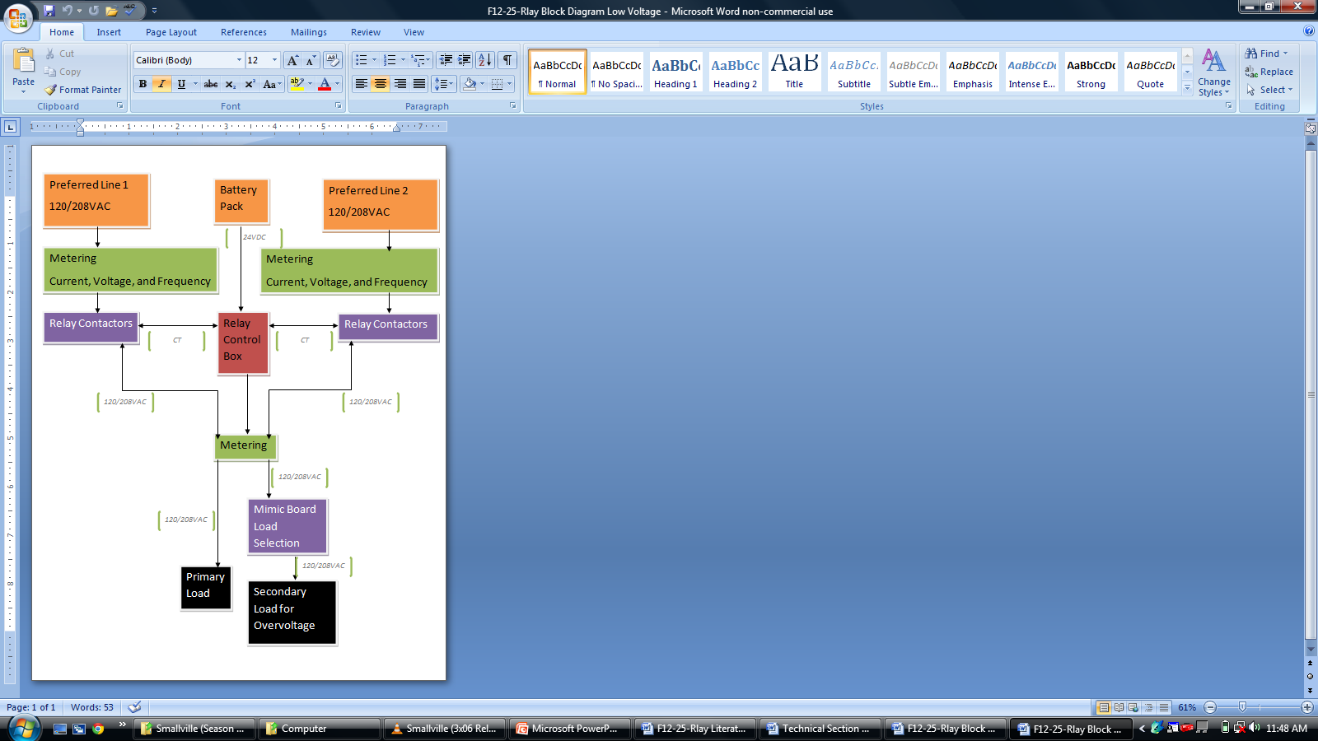

High Voltage Diagram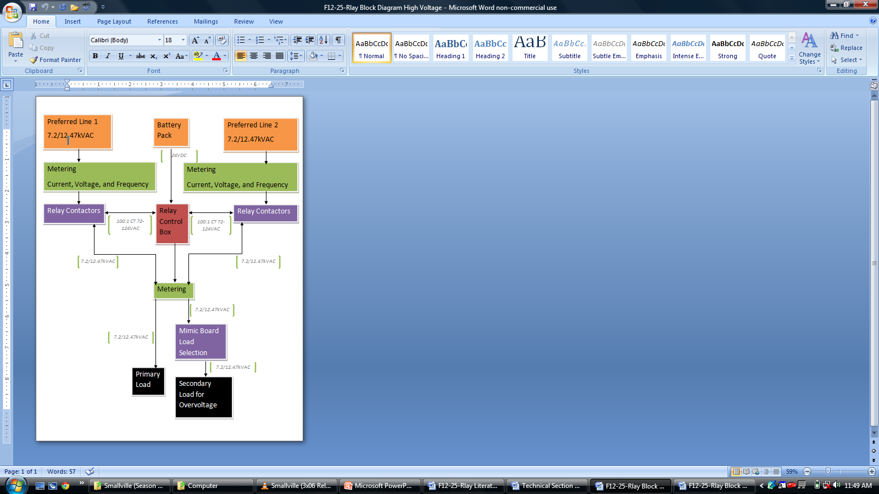

# Design Basis

|  |  |
| --- | --- |
| Basis of Design | Date |
| Request for Proposal | 9/11/2012 |
| Ameren Specifications | 9/6/2012 |
| Saluki Engineering Company Standards | 2012 |

# Subsystems

## Load Design

The load for the mimic board simulates the actual customer. In this case it draws power from the system and without the load there would be no need for the lines, or worries about protecting the lines. The load will be simulated through a resistor bank with led lights to show the active use of power, the voltage used will be 208V with a current of 20A. This section of the design will dictate the power consumption for the settings and the size of the contactors which it directly depends upon in return. The amount of power provided must be able to handle the load in this design. The load design is responsible for creation of the over current to the system.

## Power Circuit

The Power System for the SEL-351S provides continuous usable electrical energy to the source terminals on the controller. The required voltage is 24VDC and is provided by a battery pack that utilizes 4-12v batteries. Due to faults and other transient conditions the power that feeds into the substation where this controller is located has the possibility to be disconnected abruptly which means that if the SEL-351S is directly fed by the incoming source, it will lose power and any possibility of remote control or usability. The instrumentation also relays information back to the controller and this is what allows all the design making capabilities to happen. Based on these inputs and the current programming set by the client (Table 5), the controller will respond in a desired way to allow automatic transfer between two lines and fault protection.

## Metering

Metering will be used in unison with the cases to determine the capability and functionality of the control box. Voltmeters and Ammeters will be used. Each phase of the two incoming power lines will have a voltmeter attached to it in parallel. These voltmeters are used to display that the phases of the line are live and are working. When cutting off individual phases for testing these meters will display 0 volts to show that the line is dead. There will also be voltmeters attached to each phase of the line coming from the relay control box to the load. These will act the same way as the previously mentioned voltmeters. Each voltmeter will be rated at 120-140 Volts so that if there is any fluctuation from the power supply of 120V single phase, the meter will still be able to handle it. Voltmeters will not be used for the three phase voltage as a whole. If any of the three single phase voltages deviate from the expected voltage, it will be known that the line to line voltage has changed. The other meters used in this project are ammeters. They will be used with current transformers to display the current of the load to display possible overcurrent scenarios. The current transformers are necessary to step down the current of the line so that the ammeters used will not be damaged by the high current.

## Relay Switches

The type of relay switch that will be used is the three pole double throw type. This type of relay switch will allow the three phases of the line to be incoming to one relay as opposed to a single pole relay where three of them would be needed. This is because each of the poles has a contact that accepts an incoming line. It also will be able to handle the voltage and amperage of a three phase line. This relay is also good for switching quickly so that there is minimal time needed to make the switch. The relay switches will be paired with led lights. These lights will tell when the line is open or closed according to what is being tested.

## Control Box

The SEL 315s Relay protection system is used to monitor and control each phase of the incoming and outgoing lines. It is the control system for the relay switches and it uses current transformers to monitor the lines. The relay box can be programmed to react to a multitude of line scenarios. The relay will be programmed in ladder logic to react to out of phase, over voltage, overcurrent, and low voltage as well as total line failure. Each of these cases will be used to determine if a three phase line is dead. Other information that will be programmed into it will be the relay switch timing and manual override conditions that allow onsite control of the relay.

# Project Organizational Chart

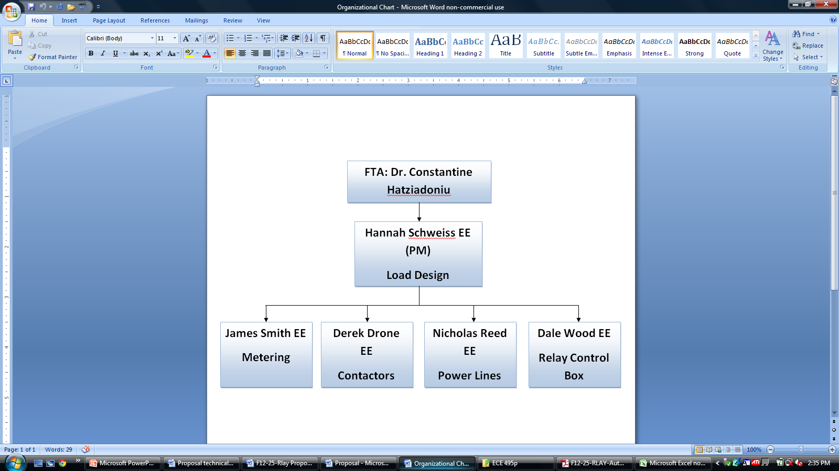

# Action Item List

|  |  |  |  |  |
| --- | --- | --- | --- | --- |
| **#** | **Activity** | **Person** | **Assigned** | **Due Date** |
| 1 | Order Material to make board | NR | 11/5/2012 | 1/18/2013 |
| 2 | Simulation of board | HS | 11/5/2012 | 1/18/2013 |
| 3 | Assembly of the board | NR | 11/5/2012 | 1/25/2013 |
| 4 | Installation of SEL 351S into board | JS | 11/5/2012 | 1/25/2013 |
| 5 | Design and build load | HS | 11/5/2012 | 1/25/2013 |
| 6 | Acquire batteries | NR | 11/5/2012 | 1/18/2013 |
| 7 | Wiring Relay switches into board | DD | 11/5/2012 | 1/25/2013 |
| 8 | Installation of load into board | DW | 11/5/2012 | 1/25/2013 |
| 9 | Order Ammeters and Voltmeters | JS | 11/5/2012 | 1/18/2013 |
| 10 | Installation of Metering | JS | 11/5/2012 | 1/25/2013 |
| 11 | Incorporate LED's with relay switches | DD | 11/5/2012 | 1/25/2013 |
| 12 | Creating logic appropriate for clients requests in software | DW | 11/5/2012 | 1/25/2013 |
| 13 | Batteries installed into board | NR | 11/5/2012 | 1/25/2013 |

# Timeline

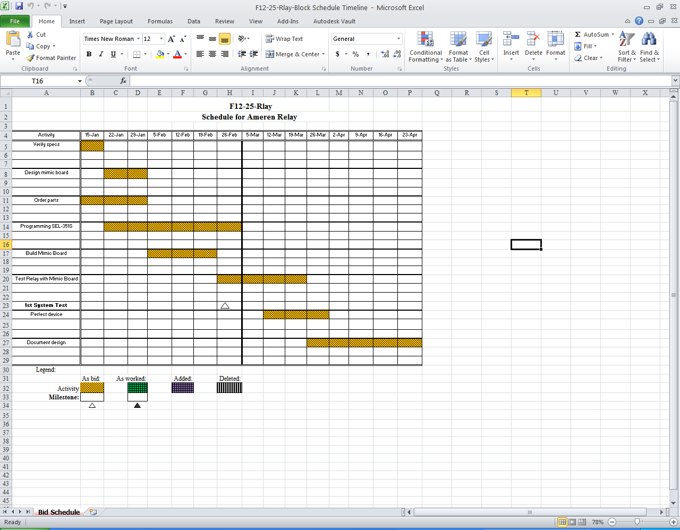

# 

# Specifications

Table 5: Specifications

|  |  |  |
| --- | --- | --- |
|  | *For board:* | *For actual:* |
| Line Voltage | 208V | 12.47KV |
| Current | 20A | 1KA |
| Fault Current | 100A | 8KA |
| Frequency | 60 Hz | 60Hz |

# 

# Budget/Resources Needed

|  |  |  |  |  |
| --- | --- | --- | --- | --- |
| Resource list with pricing |  |  |  |  |
| Item | Price | Quantity | Cost | Comment |
| Digital voltmeter | $8.72 | 9 | $78.48 |  |
| Relay Switches | $11.99 | 4 | $47.96 |  |
| Current Transformer with ammeter | $10.59 | 3 | $31.77 |  |
| Steel Sheet (Board) | $20.00 | 3 | $60.00 |  |
| Resistors |  | 8 | $0.00 | On Hand |
| Three Phase Power supply | $0.00 | 2 | $0.00 | Using test benches in power lab |
| LED's |  | 40 | $0.00 | Green and Red lights for relay switches. Blue for Load. Have LED's on hand |
| 14 Gauge Wire (10ft Wire) | $4.00 | 3 | $12.00 | Different colors for different phases |
| SEL 351S relay control box | $0.00 | 1 | $0.00 | Donated by SEL |
| Batteries (12V) | $20.00 | 4 | $80.00 |  |
| SEL AcSELerator Software with capable laptop | $0.00 | 1 | $0.00 | Software provided by SEL |
| Total |  |  | $310.21 |  |
| Budget |  |  | $500.00 |  |

# List of analyses/experiments/simulations to be performed

* Loss of three phase potential to each supply circuit independently
* Loss of single phase potential to each supply circuit independently
* Loss of potential to all supply circuits simultaneously
* Lockout operation
* Phase checks
* Interlock verification
* Control switch operations
* Transfer operation checks

Table 6: Test Conditions

|  |  |  |  |  |  |  |
| --- | --- | --- | --- | --- | --- | --- |
| ORIGINAL CONDITIONS Line #1 Preferred – Line #2 Reserve | | | | | | |
|  | Breaker Position | | Initial Condition  Voltage | | Test Condition |  |
| Case | Line #1 | Line #2 | Line #1 | Line #2 | Change | Requirement |
| 1 | C | O | Hot | Hot | Line #1  Dead | Line #1 opens after time delay and Line #2 closes (open transition) |
| 2 | C | O | Hot | Hot | Line #2  Dead | No change |
| 3 | C | O | Hot | Hot | Both Dead Simultaneously | No change |
| 4 | C | O | Hot | Dead | Line #1  Dead | No change |
| 5 | C | O | Hot | Dead | Line #2  Hot | No change |
| 6 | O | C | Dead | Hot | Line #1  Hot | Line #1 closes after time delay and Line #2 opens (closed transition) |
| 7 | O | C | Dead | Hot | Line #2  Dead | No change |
| 8 | C | O | Dead | Dead | Line #1  Hot | No change |
| 9 | C | O | Dead | Dead | Line #2  Hot | Line #1 opens after time delay and Line #2 closes (open transition) |
| 10 | C | O | Dead | Dead | Both Hot Simultaneously | No change |
| 11 | O | C | Dead | Dead | Line #1  Hot | Line #2 opens after time delay and Line #1 closes (open transition) |
| 12 | O | C | Dead | Dead | Line #2  Hot | No change |
| 13 | O | C | Dead | Dead | Both Hot Simultaneously | Line #1 closes after time delay and Line #2 opens (closed transition) |

# List of deliverables

*One-Line Drawing (208V and 12.47KV)*  
 Includes the main circuit breaker, current transformers, potential transformers, single line drawing for three-phase, not showing exact connections but where lines go

*Three-Line Drawing (208V and 12.47KV)*  
 Includes connections of all current transformers and potential transformers to the relays and bus connections, single line for single phase

*Breaker Control Schematics/Protective Relay Control Schematics (208V and 12.47KV)*  
 The 208V schematics shows all main breaker trip and close control circuits, as well as all protective relay functions and any control functions including automatic transfer logic. Includes information for understanding the protective relaying scheme that is the mimic board.  
 The 12.47KV schematics shows the entire main breaker trip and close control circuits, as well as all protective relay functions needed for high voltage lines. Has any control functions including automatic transfer logic and any information for understanding the protective relaying scheme.

*Bill of Materials*  
 The materials used to construct the mimic board, relay style numbers, ratios for current transformers and potential transformers. Also shall include ratio from mimic board 208V to 12.47KV and all necessary components

# SCOPE

The SEL 351S will be used to implement a relay protection scheme to perform automatic power restoration to a critical customer facility. A mimic board will be used to demonstrate the capabilities of the relay to switch between two incoming power lines depending on the fault with a smaller distribution voltage than that of a real distribution system. The mimic board will show the voltage topology and system status using indicator lamps and metering. These lamps will be used to display breaker open/close status, incoming line voltage, and bus voltage. The relay control box will be programmed to handle the 13 cases provided by Ameren shown in table 5.

# Appendix:

**Hannah Marie Schweiss**

636.208.3885

schweissenheimer@sbcglobal.net 10 Crystal Lake Ct.

hmschweiss@siu.edu Festus, MO 63028

**OBJECTIVE**

Electrical Engineer, power emphasis position

**EDUCATION**

**Southern Illinois University**;Carbondale, Illinois

Bachelor of Science in Electrical Engineering, May 2013

Major: Electrical Engineering

Cumulative GPA: 3.78/4.0

**Southeast Missouri State University**; Cape Girardeau, Missouri

August 2008 - May 2010

Cumulative GPA: 3.48/4.0

**EXPERIENCE**

**Ameren,** St. Louis, Missouri May 2012- August 2012

*Electrical Engineer Intern in Automated Distribution*

Assisted engineers to complete implementation of new SCADA system

**Southern Illinois University**, Carbondale, Illinois February 2012‑ Present

*Tutor*

Assisted students with Algebra, Algebra 2, Differential Equations, and Physics 2

**Ameren,** St. Louis, Missouri May 2011- December 2011

*Electrical Engineer Co-op in Automated Distribution*

Assisted in engineering duties, and helped implement the new SCADA system.

**Crystal City Pool,** Crystal City, Missouri May 2009- August 2010

*Lifeguard*

**Wal-Mart**, Festus, Missouri May 2008-August 2008

*Sales Associate*

**SKILLS**

* Knowledge of computer programming (C++ and Python)
* Use of AutoCAD, Matlab, and SCADA

**HONORS**

* Sigma Alpha Lambda
* Tau Beta Pi. Thespian Society
* Delegate at the International Science and Engineering Fair, Phoenix, Arizona

**ACTIVITIES**

* Member, IEEE
* Officer, Tau Beta Pi
* Member, Swing Dance Club



**Nicholas J Reed**  
3545 Deer Ridge Rd, Goreville, IL 62939  
Home Phone: 708-466-9027 | Email: 396BBC@gmail.com

**ELECTRICAL ENGINEER**  
*Seeking an Entry-Level Position within the Power Systems Engineering Sector*

**Soon to be BSEE graduate (06/2012) and EIT test taken** for a major solar power solutions manufacturer. Possess the analytical abilities and technical skills necessary for engineering innovative designs and applications. Solid understanding of electrical engineering theory, industry-standard circuit design, testing tools and power systems engineering.

**Education**

Southern Illinois University, Carbondale, IL  
**Bachelor of Science in Electrical Engineering,**5/2013

**GPA: 2.901/4.000**

* ***Activities:***IEEE
* ***Senior Capstone Design Project:*** Completed design work for client Ameren Corporation on automatic transfer between two sources utilizing Schweitzer SEL-351S relay controller and AcSELerator Quickset software
* ***Relevant Courses:***Digital Electronics(VLSI), Circuit Theory, Analog Electronics/Circuits, Logic Design, Signals & Systems, Sustainable Electric Energy, Verilog Hardware Description Language (HDL) & Digital Design, Power Systems Analysis, Power Systems Engineering, Power Electronics

**Engineer in Training (EIT) --**Taken the Fundamentals of Engineering (FE) exam, 10/2012 \*\*\***Waiting for results\*\*\***

John A. Logan College, Carterville, IL

**Associate in Science- Engineering Science , 12/2010**

**Experience**

* **2nd Assistant Manager , Advance Auto Parts**

Marion, IL August 2009 - Present

Responsibilities include assisting general manager, closing/ opening store, and customer service. Skills gained; problem solving, critical thinking and intrapersonal skills.

ASE Certified Parts Specialist

* **Auto Mechanic, Pep Boys Auto**

Chicago Ridge IL, October 2006 - January 2008

Responsibilities include diagnose and repair automobiles also perform preventative maintenance, also remain steady fast in an ever changing industry. Skills gained; problem solving and efficiency while working together on a team.

**Technology Summary**

AutoCAD

Programming Languages (C++, Java)

MatLab/Simulink

Microsoft Office Suite

PowerWorld

Xilinx

**Dale R. Wood**

**(618)-315-5023**

**dalerwood@gmail.com**

|  |  |
| --- | --- |
| Permanent address:  213 Northwood Lane  Salem, IL 62881 | College Address:  8 long lane  Carbondale, IL 62902 |

**Education:**

Bachelor of Science in Electrical & Computer Engineering, May 2013

Southern Illinois University Carbondale, IL 62901

GPA 2.9

**Work Experience:**

Event Coordinator SIUC Morris Library Affairs, Carbondale IL.

Student Job from September 2011- Current

- Communication

Wilderness Guide (interpreter), Northern Tier High Adventure Base, Ely MN.

Summer position from May 2011-August 2011

- Required to be calm under extreme circumstances

- Leadership

- Team building

Computer and Electronics Technician, RA Computers, Salem IL.

November 2008- August 2010

-Repaired computers, TVs, cellphones, and any other electronic device

-Set up small business networks

Additional staff, Brough Automotive, Salem IL.

September 2008-May 2010

**Activities:**

President of W9UIH Amateur radio Club, Spring 2011 to Current

**Awards:**

Eagle Scout.

**Interests:**

Outdoors, high adventure, Amateur Radio, DIY electronics, illustration, Running.

# References:

[1] " SEL-351 Protection System," *selinc.com*. [Online]. Available: https://www.selinc.com/SEL-351/. [Accessed: Sept. 30, 2012].

[2] “Distribution Product Comparison Chart,” *selinc.com*. [Online]. Available: https://www.selinc.com/distributionprotection/ .[Accessed: Sept. 30, 2012].

[3] “Specifications Guide of Overcurrent Protection Relays for medium voltage application,” *http://www.siemens.com/entry/cc/en/*. [Online]. Available: http://siemens.siprotec.de/download_neu/index_e.htm . [Accessed: Oct. 2, 2012].

[4] “SEL-351S Protection System Relay Guideform Specification,” *selinc.com*. [Online]. Available: https://www.selinc.com/SEL-351S/ .[Accessed: Sept. 30, 2012].

[5] CEE PRAG, *Application Guide for the choice of Protective Relays*, Paris, France: CEE Relays [Accessed: Oct 2, 2012]

[6] R Hedding, R Haas, *IEEE Guide for Protective Relay Applications to Power Transformers,* Power Systems Relay Committee of the IEEE Power Engineering Society, March 2000 Available:

http://samgor.com/pdf/IEEE%20C37.91-2000.pdf [Accessed: Oct 2, 2012]

[7] Marciniak, P.; Kulesza, Z.; Napieralski, A.; Kotas, R.; , "Scripting languages for simulations in modern SCADA systems," *Mixed Design of Integrated Circuits and Systems (MIXDES), 2010 Proceedings of the 17th International Conference* , vol., no., pp.613-618, 24-26 June 2010 Available: http://ieeexplore.ieee.org.proxy.lib.siu.edu/stamp/stamp.jsp?tp=&arnumber=5551274&isnumber=5551270

[Accessed: Sept 29, 2012]

[8] Wang Chunlei; Fang Lan; Dai Yiqi; , "A Simulation Environment for SCADA Security Analysis and Assessment," *Measuring Technology and Mechatronics Automation (ICMTMA), 2010 International Conference on* , vol.1, no., pp.342-347, 13-14 March 2010 Available: http://ieeexplore.ieee.org.proxy.lib.siu.edu/stamp/stamp.jsp?tp=&arnumber=5459612&isnumber=5458485

doi: 10.1109/ICMTMA.2010.603 [Accessed: Sept 29, 2012]

[9] Silva, J.M.S.; Phillips, J.R.; Silveira, L.M.; , "Efficient Simulation of Power Grids," *Computer-Aided Design of Integrated Circuits and Systems, IEEE Transactions on* , vol.29, no.10, pp.1523-1532, Oct. 2010 Available: http://ieeexplore.ieee.org.proxy.lib.siu.edu/stamp/stamp.jsp?tp=&arnumber=5580215&isnumber=5580212

doi: 10.1109/TCAD.2010.2061512 [Accessed: Oct 1, 2012]

[10] Chassin, D.P.; Schneider, K.; Gerkensmeyer, C.; , "GridLAB-D: An open-source power systems modeling and simulation environment," *Transmission and Distribution Conference and Exposition, 2008. T&D. IEEE/PES* , vol., no., pp.1-5, 21-24 April 2008 Available:

http://ieeexplore.ieee.org.proxy.lib.siu.edu/stamp/stamp.jsp?tp=&arnumber=4517260&isnumber=4517029

doi: 10.1109/TDC.2008.4517260 [Accessed: Oct 2, 2012]

[11] C.R. Mason, “Fundamental Relay-operating principals and characteristics”, in *Art and Science of Protective relaying.* [Ebook] Available: http://www.gedigitalenergy.com/multilin/notes/artsci/

[12] "Notes on Multimeters," *www.eee.metu.edu.* [Online]. Available: http://www.eee.metu.edu.tr/~ee214/documents/NotesOnMultimeters.pdf. [Accessed: 10/2/2012].

[13] K.B. Klaassen, *Electronic Measurement and Instrumentation*, New Edition, New York, NY: Cambridge University Press, 2003, 121-124.

[14] G. Hasmi, M. Tehtonen, M. Nordman. *Calibration of in-line partial discharge measuring system using Rogowsi coil in covered-conductor overhead distribution networks.* :The Institution of Engineering and Technology, 2009, p. 5-13.

[15] N. Mohan, B. George, V. Kumar, *Virtual Instrument for Testing of Current and Voltage Transformers,* Sorrento, Italy: Technology Conference, 2006, p.1163-1166.

[16] S. Yang, Q. Zhu, Z. Liu, *Research on Application of Power System Reliability Model Based on Principal-agent Mechanism,* :Academy Publisher, 2012, p.339-345

[17] S. Kunsman, *The Protective Relay Evolves,* POWERGRID INTERNATIONAL, 2011, p.24-29